YEAR 12 CHEMISTRY

TEST 4 Oxidation and Reduction

ANSWERS

MULTIPLE CHOICE ANSWER SHEET

Questions 1-15

1 | a  b  c  d  |  | 9 | a  b  c  d 
2 | a  b  c  d  |  | 10 | a  b  c  d 
3 | a  b  c  d  |  | 11 | a  b  c  d 
4 | a  b  c  d  |  | 12 | a  b  c  d 
5 | a  b  c  d  |  | 13 | a  b  c  d 
6 | a  b  c  d  |  | 14 | a  b  c  d 
7 | a  b  c  d  |  | 15 | a  b  c  d 
8 | a  b  c  d 
(15 marks)

PART 2 : SHORT ANSWER (13 Marks)

Answer questions in the space provided. Note that NOT all questions carry equal marks.

1. This question refers to the diagram and information below. Use labels to show on the diagram, the
(a) anode;
(b) cathode;
(c) direction of the electron flow, and
(d) direction of migration of ions in the salt bridge.

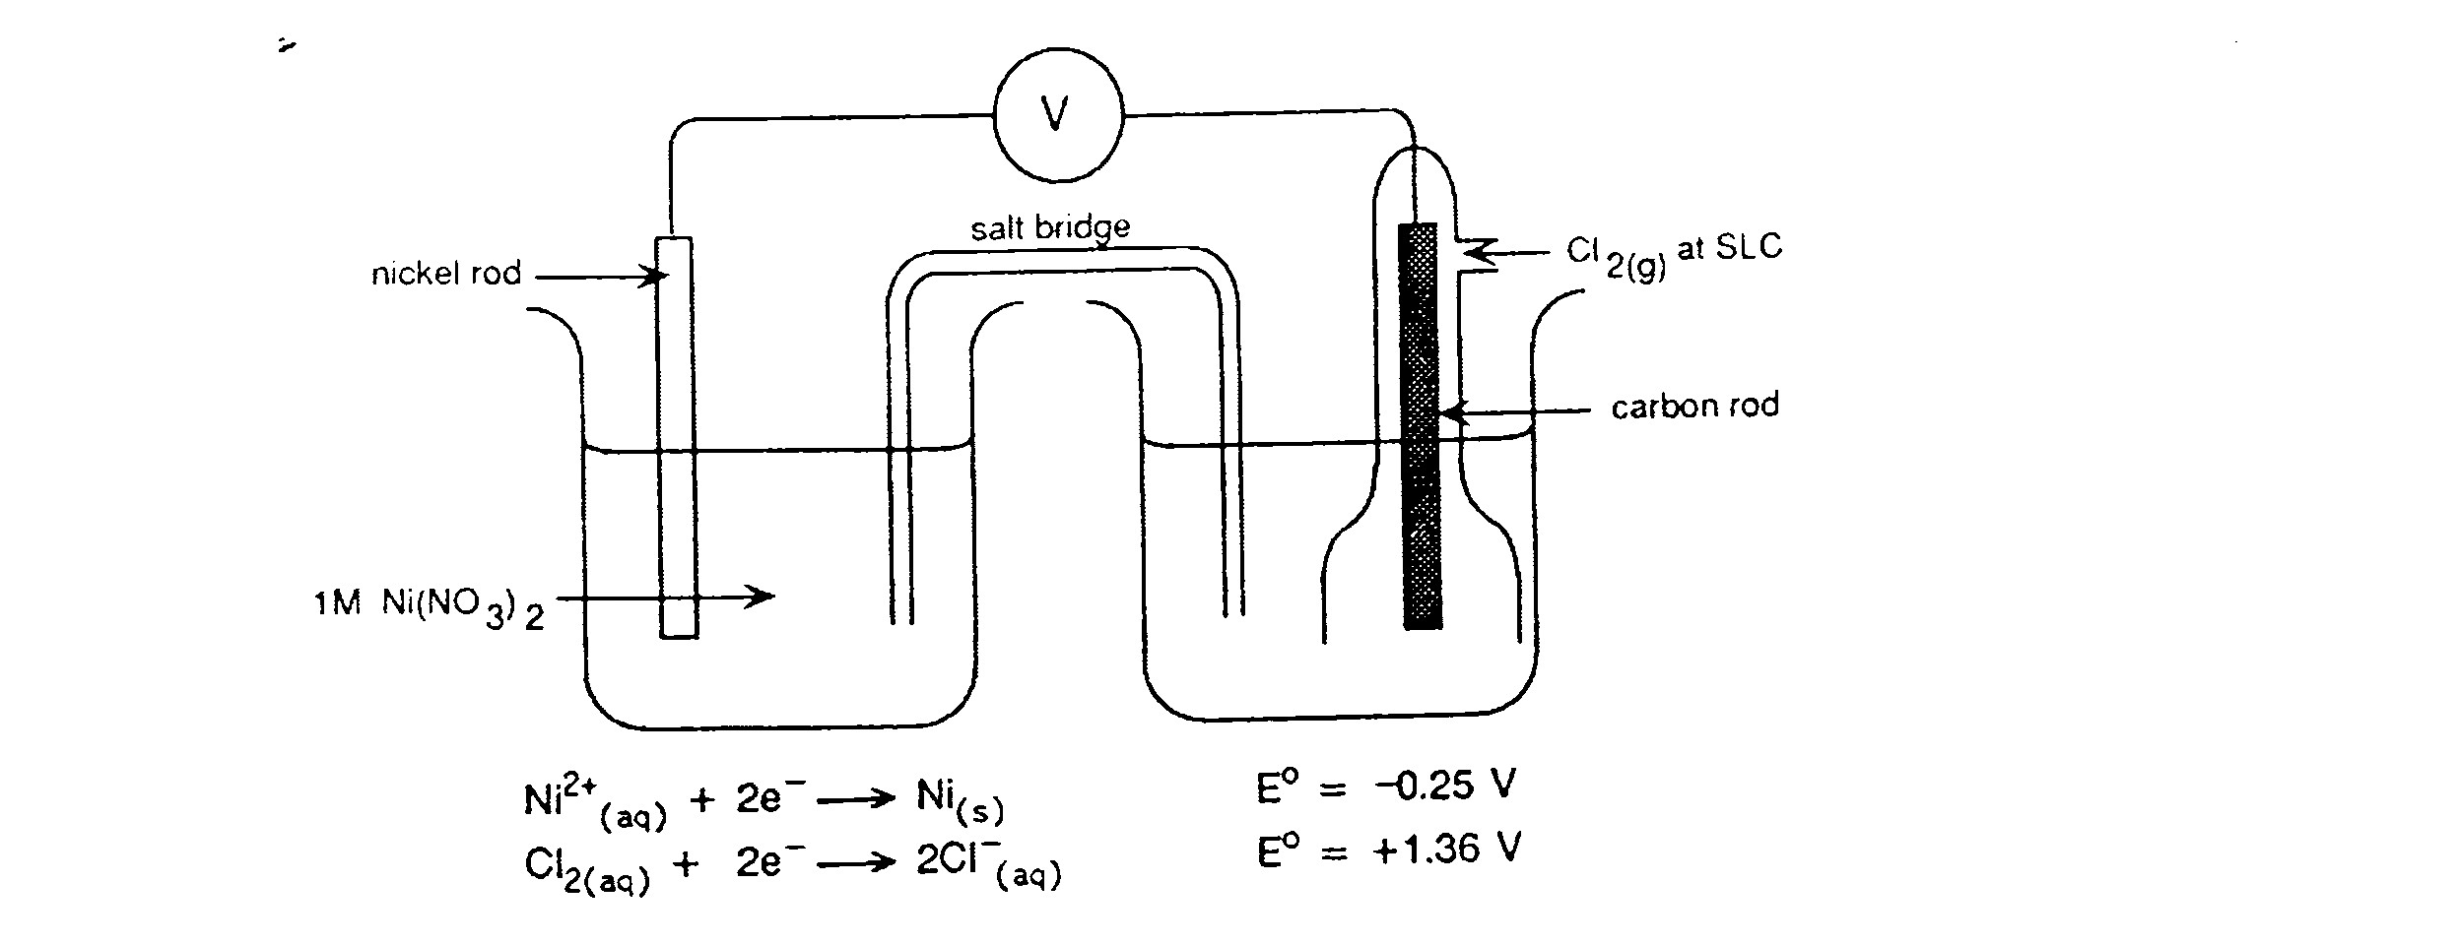
(iv) –‘ve ion flow
(iv) +‘ve ion flow
(i) ANODE
(ii) CATHODE
(iii) e⁻ flow

(4 marks)

Write the overall chemical equation for this electrochemical cell:

Cl₂(aq) + Ni(s) 2Cl⁻ (aq) + Ni²⁺ (aq)
(1 mark)

2. A student was given freshly prepared solutions of iron (II) sulfate, sodium bromide, bromine water and acidified potassium permanganate. She carried out the tests shown in (a), (b) and (c) below. For each test, record any observed colour changes she may have seen, then write a net ionic equation to account for the observation.
(1 obs’n, 1 equation)
(a) Small amounts of the iron (II) sulfate solution and bromine water were mixed and shaken.

Observation: Pale green and orange solutions form a brown solution Equation: 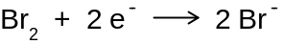
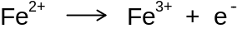

(b) Small amounts of the iron (II) sulfate solution and potassium permanganate solutions were mixed and shaken.

Observation: pale green and purple solutions change to orange/brown
Equation:

(c) Small amounts of potassium permanganate solution and sodium bromide were mixed and shaken.

Observation: Purple to orange

Equation:
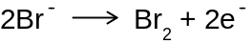

(d) From these results, state below, which of the four solutions contained:

(i) the most powerful oxidant Permanganate ion

(ii) the most powerful reductant Iron (II) ion (8 marks)

PART 3: CALCULATION (12 marks)

Dichromate ion (Cr₂O₇²⁻) may be used in a titration to analyse hydrogen peroxide solutions.

(a) from your table of Standard Reduction Potentials, obtain

(i) the half equation for the reduction of dichromate ion (in acid conditions) to give chromium(III) ion, and

(ii) the half-equation for the oxidation of hydrogen peroxide (in acid conditions) to give oxygen.

(iii) Use these half-equations to construct the redox equation for the reaction that occurs when potassium dichromate solution is added to a solution containing hydrogen peroxide and sulfuric acid. (4 marks)

Cr₂O₇²⁻ + 14H⁺ + 6e⁻ 2Cr³⁺ + 7H₂O
(x 3) 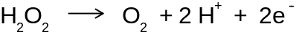
Cr₂O₇²⁻ + 8H⁺ + 3H₂O₂ 2Cr³⁺ + 7H₂O + 3O₂

(b) Hairdressers use hydrogen peroxide to bleach hair. An analyst uses a pipette to transfer 20.00mL of commercial hairdressers’ hydrogen peroxide to a 250.0mL volumetric flask, and she makes the volume up to the mark with distilled water. She places 20.00mL portions of this solution in a titration vessel , adds 5.00mL of 2.00 mol L⁻¹ sulfuric acid, and titrates the mixture with 0.02056 mol L ⁻¹ potassium dichromate. She records the following titration figures:

Final reading (ml) | 29.5 | 29.53 | 29.35 | 28.74 | 28.62
Initial reading (ml) | 0.11 | 1.55 | 0.41 | 0.81 | 0.66

Calculate the appropriate value for the volume of potassium dichromate solution required for titration (2 marks)

Discarding readings 1 and 3, use average of other 3 readings.

(27.98 + 27.93 + 27.96) / 3 = 27.96 mL

(c) Calculate the concentration, in mol L⁻¹, of the original commercial hairdressers’ hydrogen peroxide. (6 marks)

In titre volume, n(Cr₂O₇²⁻) = c(Cr₂O₇²⁻).V(Cr₂O₇²⁻)
= 2.056 x 10⁻² mol.L⁻¹ x 27.96 x 10⁻³ L
= 5.749 x 10⁻⁴ mol (1)

In 20 mL sample n(H₂O₂) = n(Cr₂O₇²⁻)x3
= 3 x 5.749 x 10⁻⁴ mol
= 1.725 x 10⁻³ mol (1)

So [H₂O₂] in 20 mL sample = n/V = 1.725 x 10⁻³ mol / 20 x 10⁻³ L
= 8.625 x 10⁻³ mol L⁻¹ (1)
Then n(H₂O₂) in 250 mL = [H₂O₂].V(H₂O₂) = 8.625 x 10⁻³ mol L⁻¹ x 0.250 L
= 2.156 x 10⁻² mol (1)

and [H₂O₂] in 20 mL sample of commercial solution
= n/V = 2.156 x 10⁻² mol / 20 x 10⁻³ L
= 1.078 mol L⁻¹ (2)

i.e. concentration of hydrogen peroxide in commercial solution is
1.08 mol L⁻¹

END OF TEST Total: 40 Marks

